
Code & Conquer - Data Analysis Into Car Depreciation & Future Pricing

1. Introduction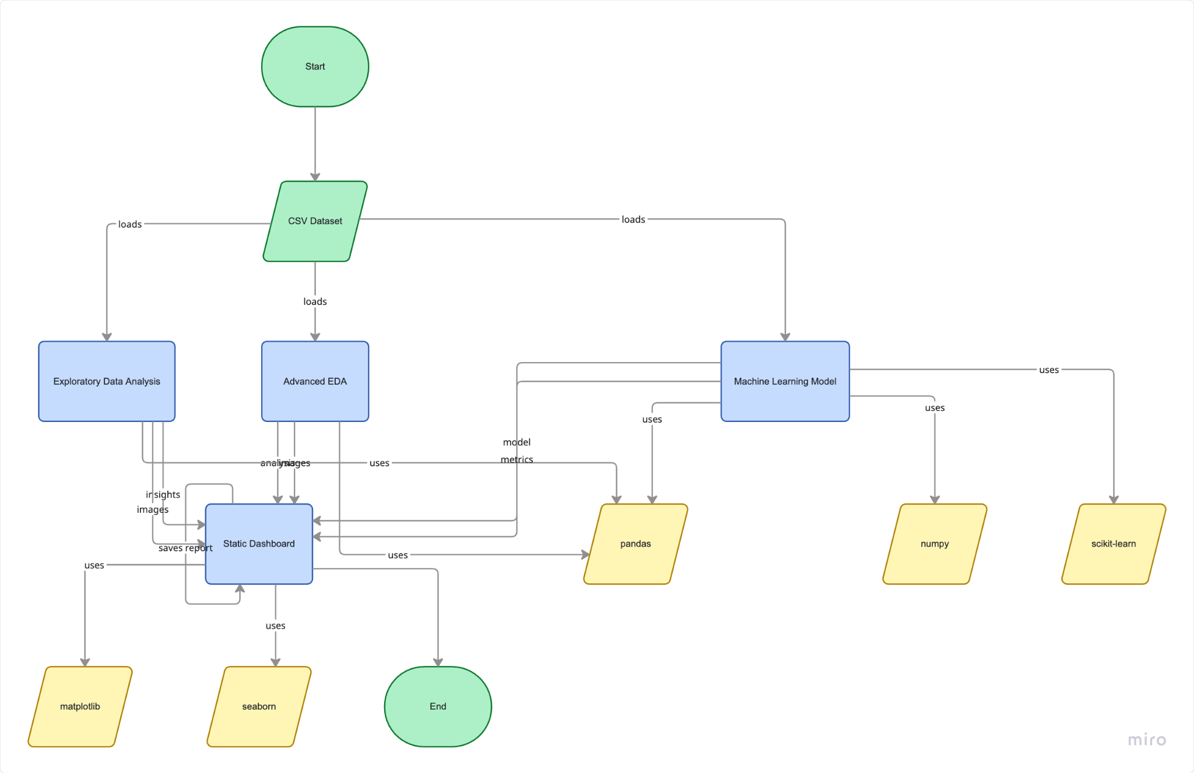
The modern automotive market is a complex ecosystem. For most people, buying a car is one of the biggest financial commitments they will ever make. However, unlike real estate, a car is fundamentally a depreciating asset. From the exact moment a brand new vehicle leaves the dealership, its financial value begins to drop.
Understanding how this value disappears is incredibly important. It helps everyday buyers save money, allows dealerships to manage inventory risks, and provides the foundation for building predictive pricing tools.
We recently analysed a massive dataset of car sales to uncover the hidden rules of the secondary car market. Our ultimate goal is simple. We want to predict how much a car will be worth five to ten years from now based on its age, its mileage, and its exact specifications.

2. Key Findings from the Visual Data
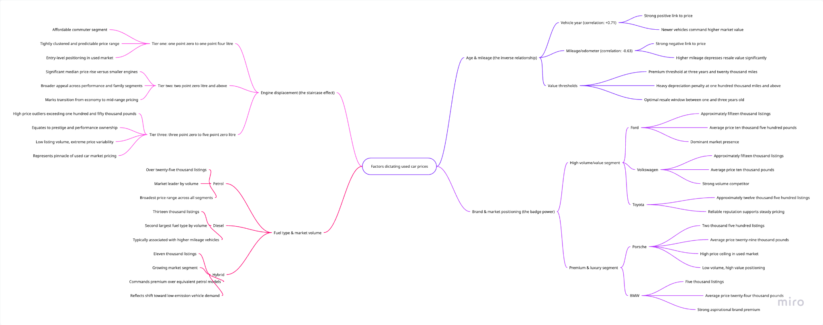
To understand the future, we first have to understand the present. The visual charts and data points from our analysis clearly reveal four main factors that dictate a car's price.
The Impact of Age and Mileage
The correlation heatmap provides a crystal clear numerical picture of what buyers care about most. The year a car was manufactured has a strong positive correlation of 0.71 with its asking price. Newer cars simply cost a premium.
On the flip side, the mileage odometer acts as a running tally of wear and tear. The heatmap shows a strong negative correlation of -0.63 between mileage and price. As the miles go up, the price predictably comes down. Buyers will pay top dollar for a three year old car with 20,000 miles, but they will heavily penalize a car that has crossed the 100,000 mile mark.
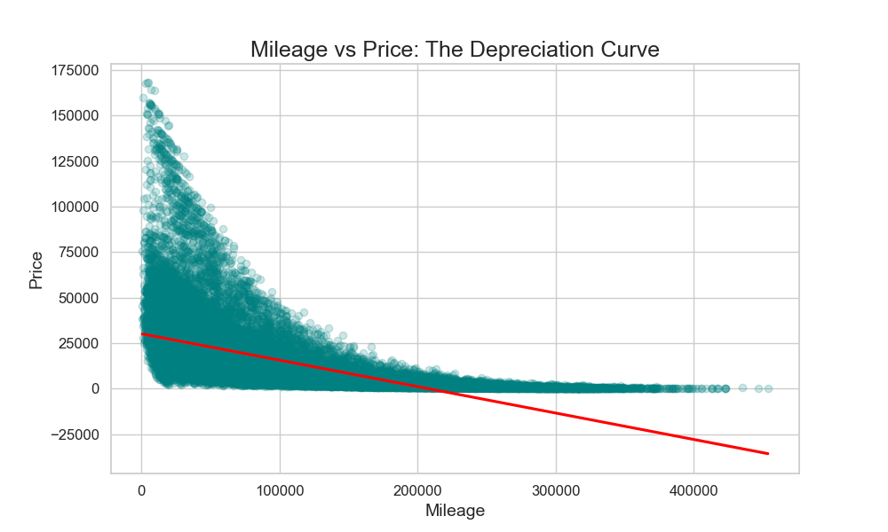
The Power of the Badge
The badge on the front grille establishes a firm baseline for a vehicle's value. Our charts showing the count of cars by manufacturer highlight a market dominated by volume. Ford and VW are the absolute leaders, with roughly 15,000 listings each. Toyota follows closely with about 12,500 cars.
However, high volume does not equal high price. The average price chart shows Ford averaging around £10,500, while VW sits near £10,000.
Luxury brands operate in a completely different reality. Porsche represents a tiny fraction of the market with just 2,500 listings, but it boasts the highest average price at nearly £29,000. BMW sits in the premium middle ground, with roughly 5,000 listings averaging £24,000. The brand completely dictates the price ceiling.
Engine Size and Power
When we look at the boxplots mapping engine size against price, a clear staircase effect appears. The market heavily links engine displacement to vehicle prestige.
Small engines ranging from 1.0 to 1.4 litres dominate the affordable commuter segment. Their prices are tightly clustered at the lower end of the graph. As the engine size increases to 2.0 litres and beyond, the median price rises significantly. Once we look at massive 3.0 to 5.0 litre engines, we see huge price outliers reaching well over £150,000. Bigger engines almost always equal bigger price tags.
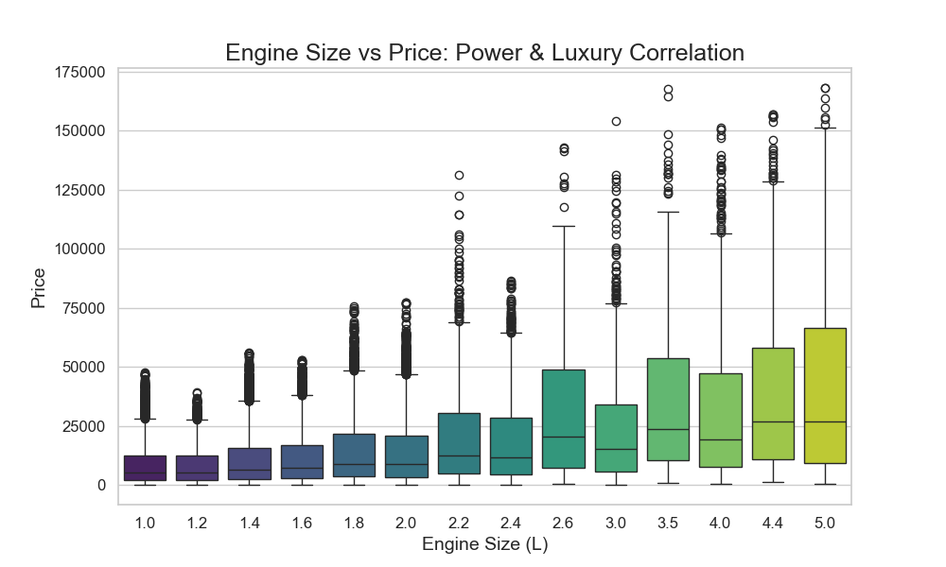
Fuel Preferences
Finally, traditional fuel still rules the used market. The bar chart breaking down fuel types shows petrol engines leading massively with over 25,000 listings. Diesel engines follow with roughly 13,000 cars, and hybrids make up the final group with 11,000 listings.

3. Market Trends and the Depreciation Curve
Depreciation is not a straight line. It is a curve that is incredibly steep at the beginning and flat at the end.
The Five Year Cliff
The most violent financial phase of a car's life happens in the first few years. The moment a new car becomes a used car, it loses a massive chunk of its retail value. By the time a vehicle reaches its fifth birthday, it has typically lost around 55 to 60 percent of its original purchase price.
High Mileage Stabilization
Once that initial value evaporates, the rate of loss slows down dramatically. A seven year old car loses much less value heading into its eighth year than a brand new car loses in its first twelve months. When vehicles reach extreme age and hit 150,000 miles, their price stabilizes. At that point, the badge and the engine size matter much less than the simple fact that the car still safely drives. The market establishes a price floor based on basic utility.
Depreciation Curve
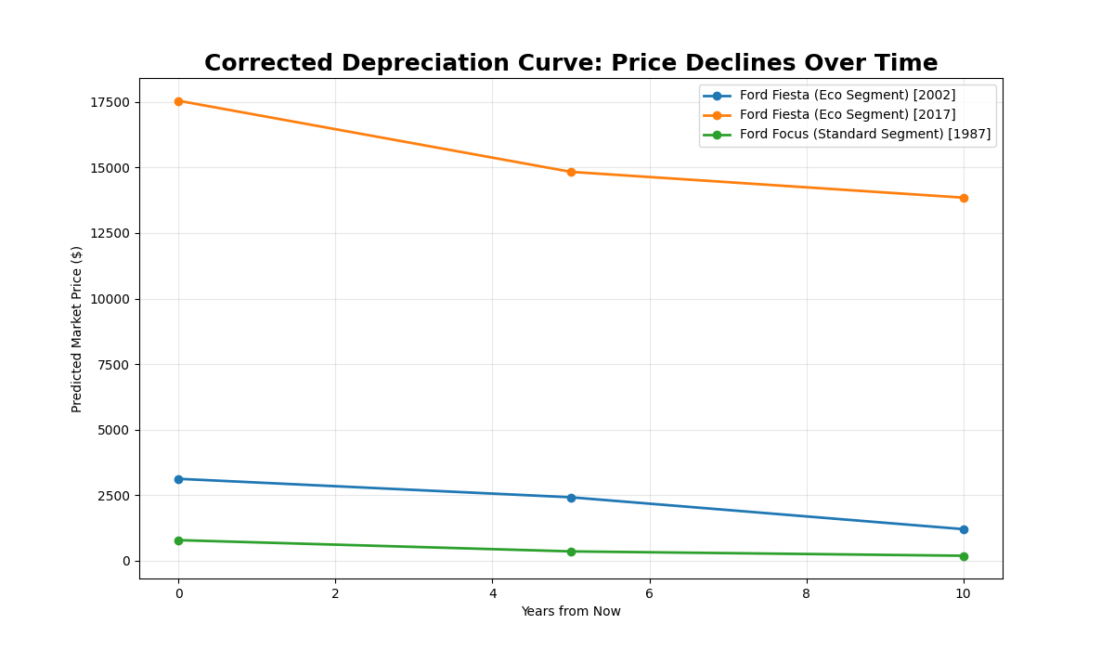

4. The Problem Statement and Our Approach
We know how cars are priced today. Now, we must turn our attention to the future.
The Goal: Predict how car prices will change over the next 5 to 10 years based on depreciation trends, vehicle age, mileage, and specifications.
To solve this, we do not need complex algorithms that nobody can understand. We just need to build a logical simulation.
We know that a car's value is tied to age and mileage. If we want to know what a 2021 Toyota RAV4 will be worth in 2026, we artificially age it by five years. Then, we add estimated future miles to its odometer. Recent data shows that the average UK motorist currently drives about 7,100 miles per year. So, for a five year projection, we add 35,500 miles to the car.
Once we have this simulated future profile, we simply look back into our current dataset to see what vehicles with those exact specs are selling for right now. The current market acts as a mirror to reflect the future.

5. Predictive Thinking in Action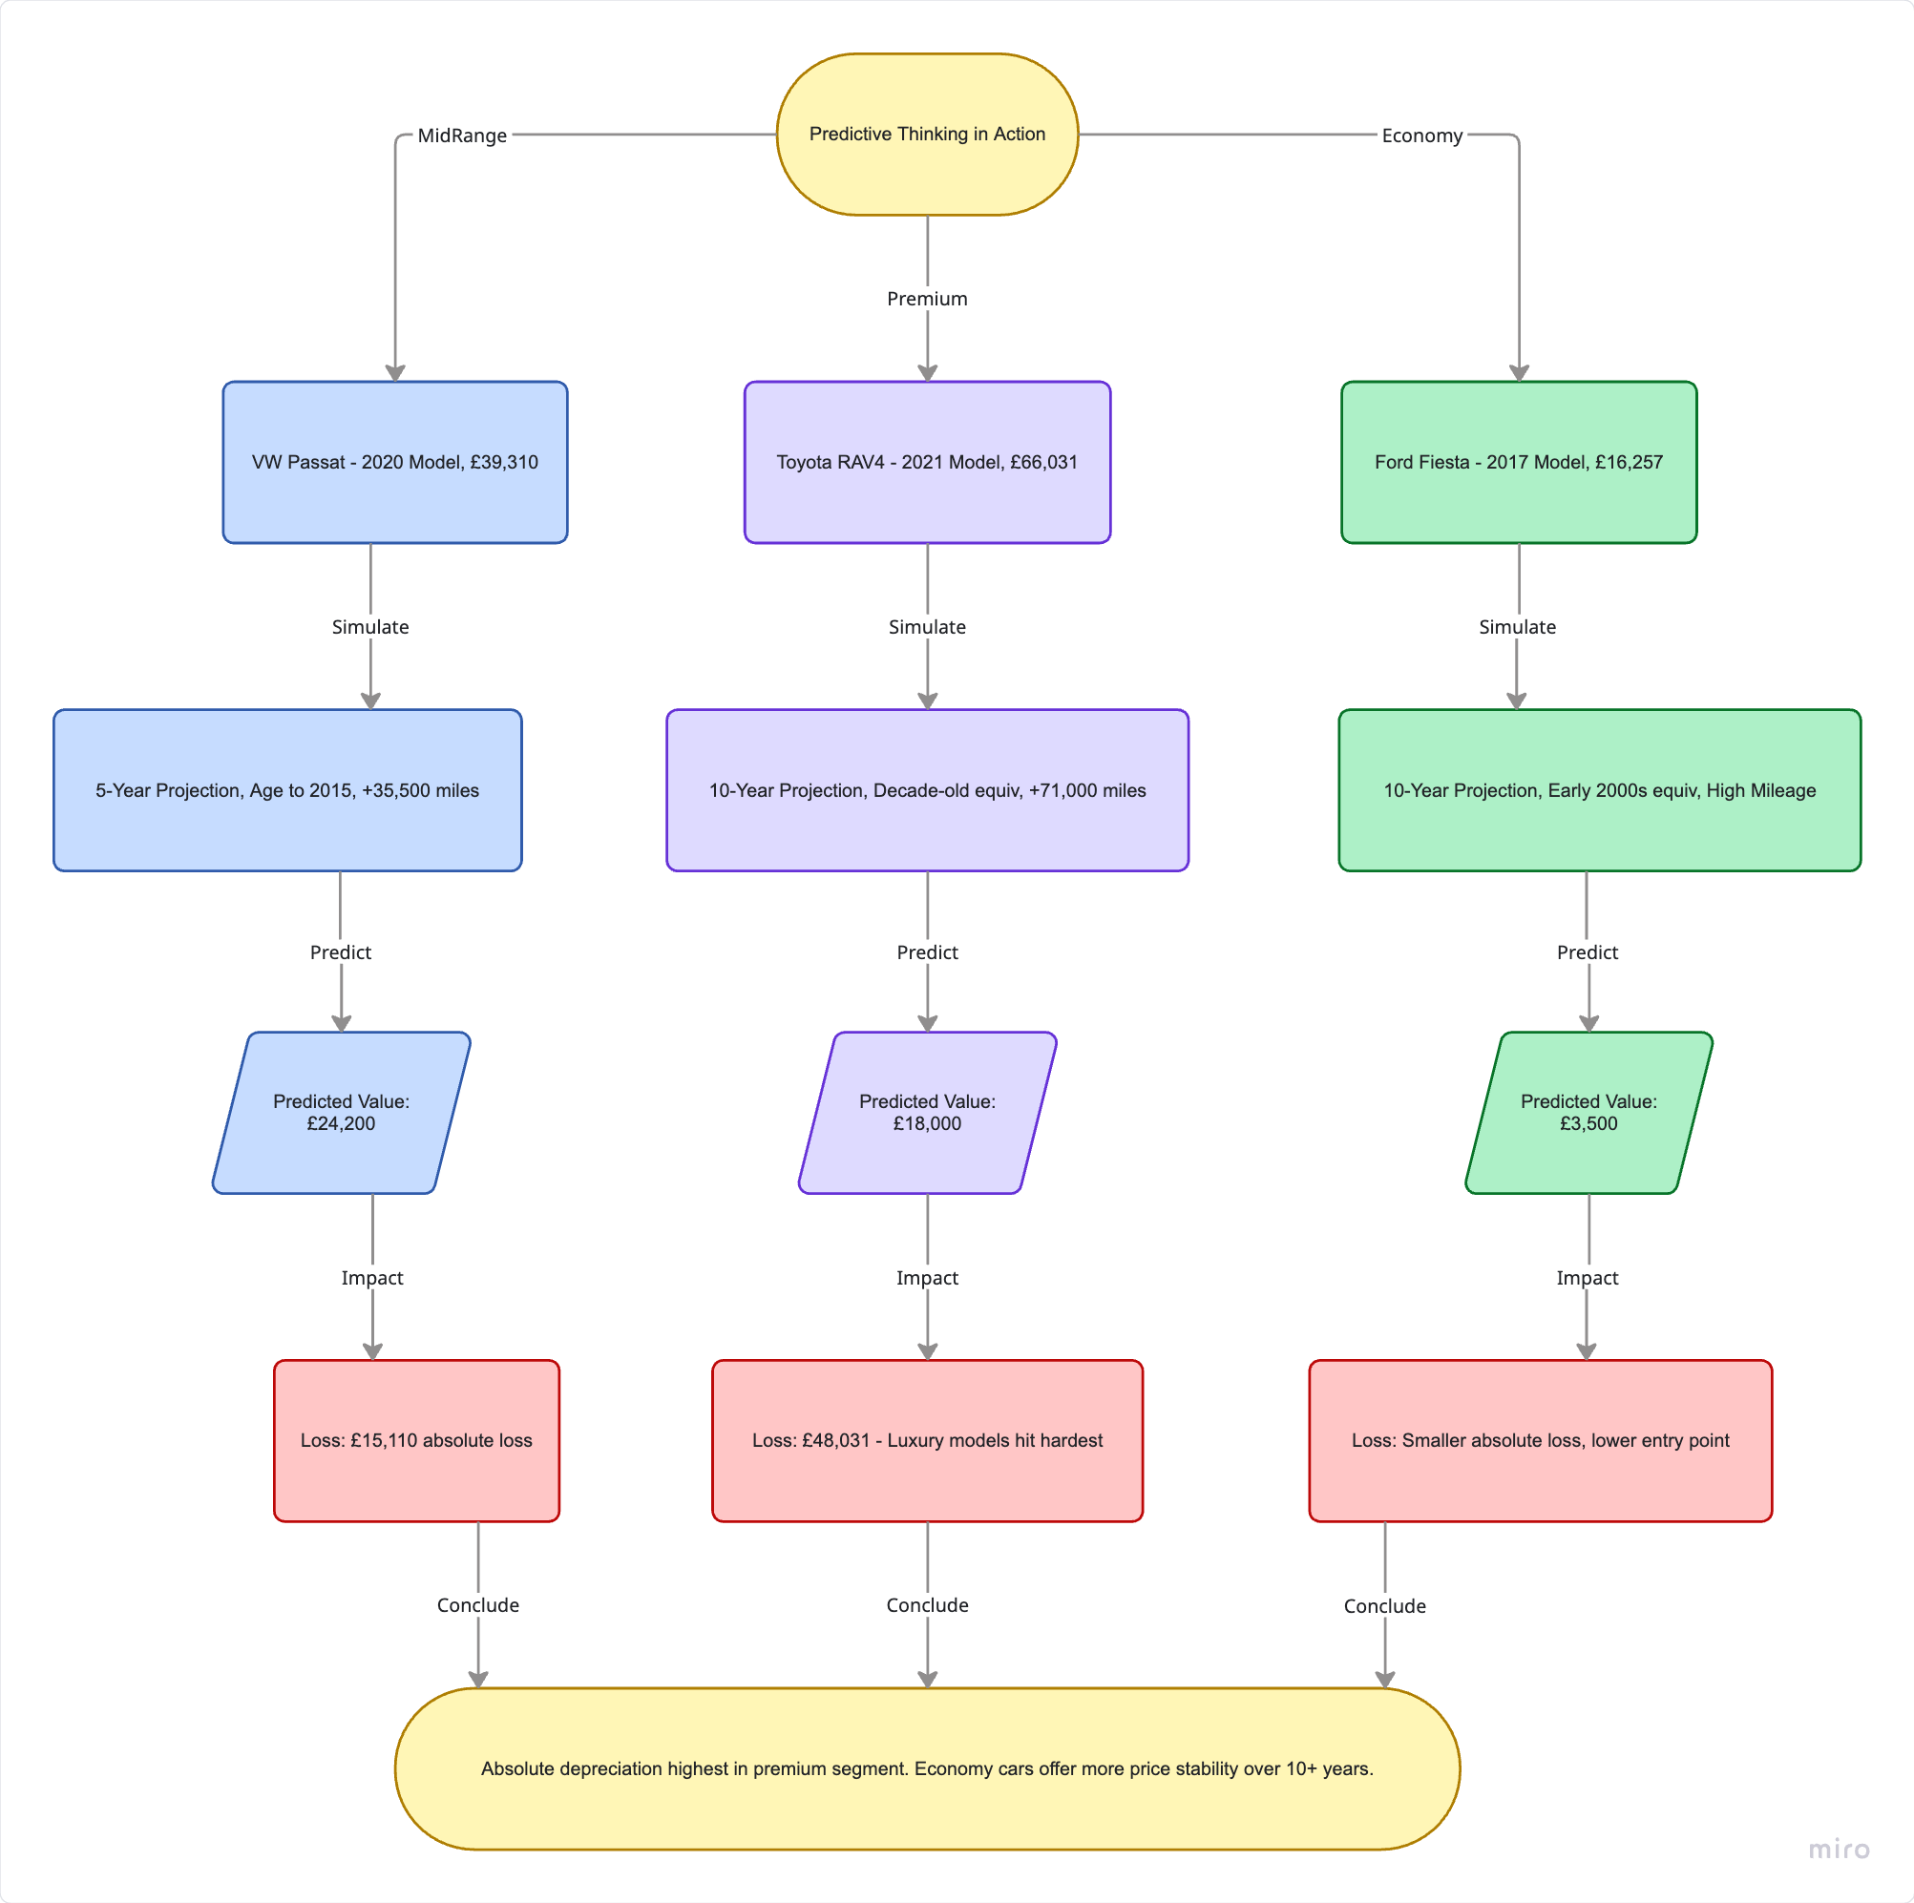

Let us walk through how this predictive logic works using real world averages and our visual data trends.
Scenario 1: The Mid Range Commuter
Imagine a 2020 VW Passat currently priced at £39,310.
If we project five years into the future, we age it to the equivalent of a 2015 model today and add roughly 35,500 miles. Looking at our historical data for similar 2015 models, we can estimate its future price will land near £24,200. That is a substantial £15,000 drop.
Scenario 2: The Premium SUV
Consider a highly desirable 2021 Toyota RAV4 currently listed at £66,031.
Fast forward ten years. We age the vehicle by a full decade and add 71,000 miles to the clock. By looking at similar decade old Toyota SUVs in our dataset, we see the long term reality. The vehicle will likely be worth around £18,000. It loses a staggering £48,000 over ten years. Luxury and high end models suffer the biggest absolute financial losses.
Scenario 3: The Economy Hatchback
Finally, let us look at a 2017 Ford Fiesta priced at £16,257.
If we project ten years ahead, we look for early 2000s models with high mileage. We can estimate a future value of roughly £3,500. Because the Fiesta started at a much lower price point than the RAV4, its absolute monetary loss is far smaller.

